**Experiment 2.1**

**Name :- Yash Gupta Uid :- 20BCS5009**

**Course :- CSE Section :- 706-B**

**Subject :- Programming in Python Subject Code :- 20CSP-259**

1. **Python program to check whether the string is Symmetrical or Palindrome.**

**Code:-**

**def sym(string):**

**n=len(string)**

**mid=(n-1)//2**

**start=0**

**end=mid**

**flag=0**

**while (start<=mid and end<=(n-1)):**

**if string[start]==string[end]:**

**start+=1**

**end+=1**

**else:**

**flag=1**

**break**

**if flag==0:**

**print("{} is symmetrical".format(string))**

**elif flag==1:**

**print("{} is not symmetrical".format(string))**

**def palin(string):**

**n=len(string)**

**start=0**

**end=n-1**

**mid=(n-1)//2**

**flag=0**

**while start<=mid:**

**if string[start]==string[end]:**

**start+=1**

**end-=1**

**else:**

**flag=1**

**break**

**if flag==0:**

**print("{} is palin".format(string))**

**elif flag==1:**

**print("{} is not palin".format(string))**

**st=input("Enter string to check palindrome/symmetric :- ")**

**string=st.upper()**

**print(string)**

**sym(string)**

**palin(string)**

**Output :-**

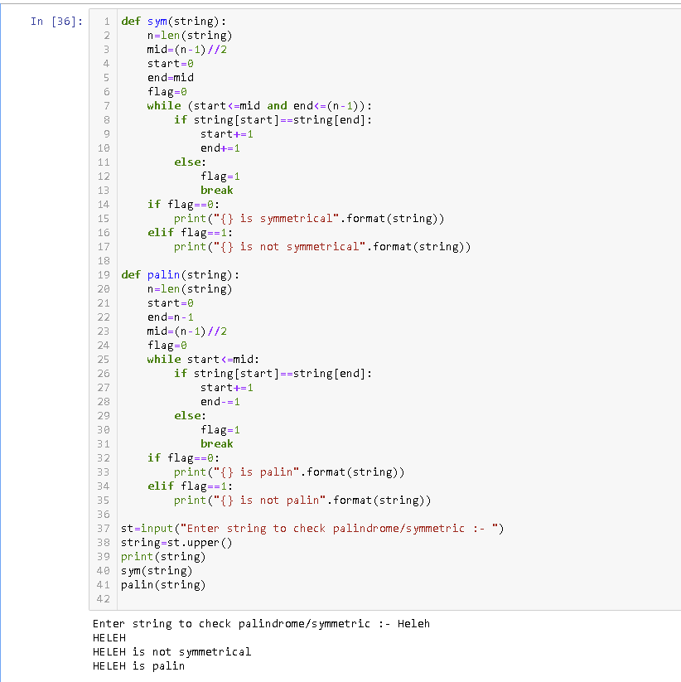

1. **Python program to find uncommon words from two Strings.**

**Code :-**

**def uncommon(a,b):**

**list_a = a.split()**

**list_b = b.split()**

**uc = ''**

**for i in list_a:**

**if i not in list_b:**

**uc = uc+" "+i**

**for j in list_b:**

**if j not in list_a:**

**uc = uc+" "+j**

**return uc**

**a = input("Enter String 1 :- ")**

**b = input("Enter String 2 :- ")**

**print(uncommon(a,b))**

**Output :-**

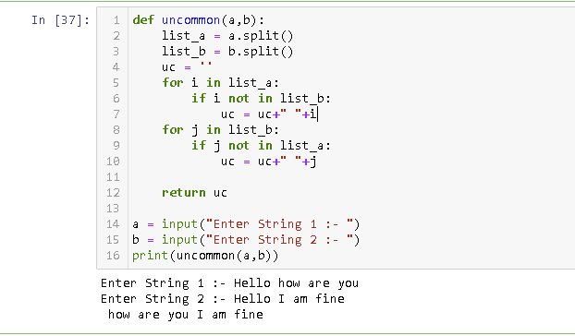

1. **Write a Python program to add 'ing' at the end of a given string (length should be at least 3). If the given string already ends with 'ing' then add 'ly' instead. If the string length of the given string is less than 3, leave it unchanged. Example:- Sample String : 'abc' Expected Result : 'abcing' Sample String : 'string' Expected Result : 'stringly'.**

**Code:-**

**def add_string(str1):**

**n = len(str1)**

**if n > 2:**

**if str1[-3:] == 'ing':**

**str1 += 'ly'**

**else:**

**str1 += 'ing'**

**print("\n",str1)**

**string=input("Enter word :- ")**

**add_string(string)**

**Output :-**

